Ideation Phase

Define the Problem Statements

|  |  |
| --- | --- |
| Date | 6 September 2022 |
| Project Name | Nutrition Assistant Application |
| Team Id | PNT2022TMID17257 |
| Maximum Marks | 2 Marks |

# Customer Problem Statement Template:

Create a problem statement to understand your customer's point of view. The Customer Problem Statement template helps you focus on what matters to create experiences people will love.

A well-articulated customer problem statement allows you and your team to find the ideal solution for the challenges your customers face. Throughout the process, you’ll also be able to empathize with your customers, which helps you better understand how they perceive your product or service.

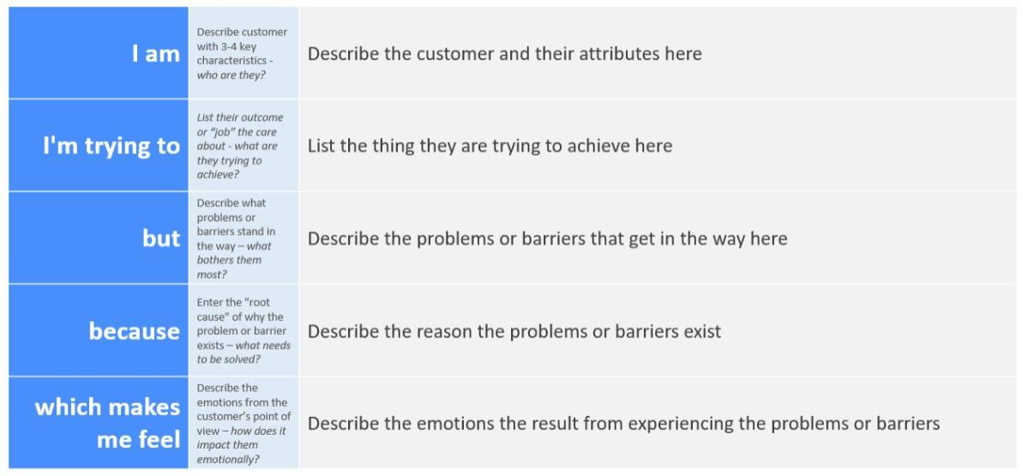

Reference: <https://miro.com/templates/customer-problem-statement/>

# Example:

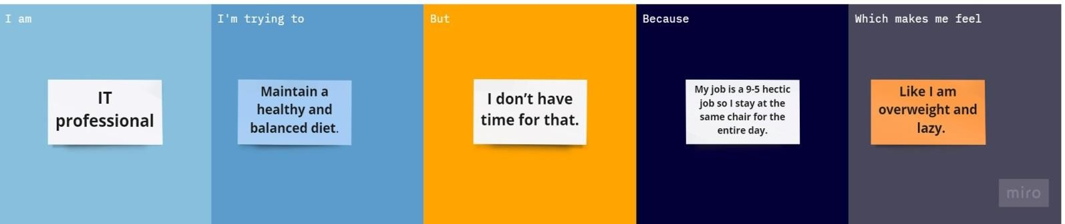

|  |  |  |  |  |  |
| --- | --- | --- | --- | --- | --- |
| **Problem**  **Statement (PS)** | **I am**  **(Customer)** | **I’m trying to** | **But** | **Because** | **Which makes me feel** |
| PS-1 | IT  professional | Maintain a healthy and balanced diet. | I don’t have time for that. | My job is a 9-5 hectic job and I stay at the same chair  for the entire day. | Like I am overweight and lazy. |
| PS-2 | Student | Improve the health and the memory power. | I am unaware of what to eat. | I don’t have more knowledge about  nutrition. | Like I am weak and I have less memory power. |